**REGex Software Services**

**Java Full Stack Development Program**

Registration I'd:  **IIPRSS1404**

Name: **Shanmukh Subhash Kumbhar**

College Name: Dr. D. Y. Patil School of Engineering And Technology, Pune.

# Subject: Assignment 4 - #Command line arguments, Scanner object

**Core Java Session 4 Assignments**

**Assignment 1:**

Accept student id, name, and marks of 6 subjects using CommandLine Arguments and Scanner.

Calculate total marks and average.

Print Student Id, Student Name, Six subject marks, total marks, and average.

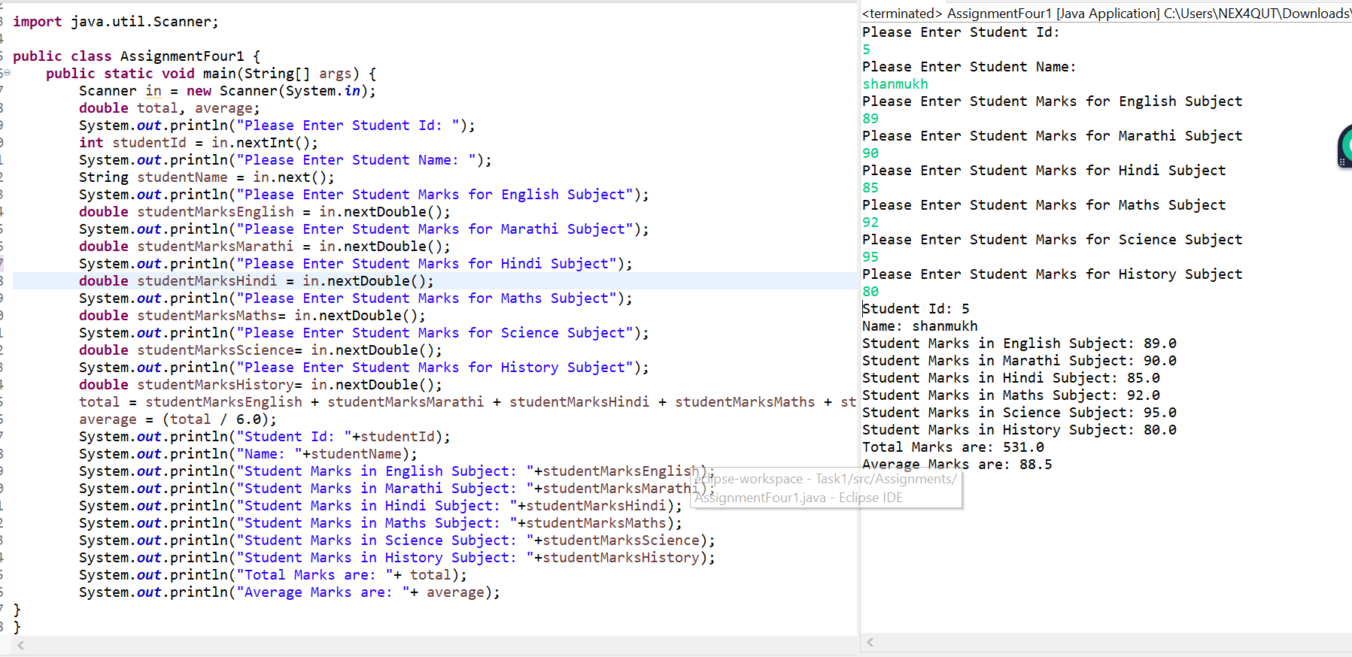

**Assignment 2:**

**Employee Salary Breakup App**

Accept Employ Id, Employ Name, Basic Salary from end user.

Calculate based on the following constraints

HRA is 2% of Basic

PF is 3% of Basic

TA is 1% of Basic

ESI is 2.5% of Basic

Gross Pay is Sum of Basic, HRA, PF, ESI and TA

Net Pay is Gross Pay minus PF.

Print

Employ id, employ name, Basic Sal, hra, pf, ta, esi, Gross Pay, Net Pay as following

**Input:**

Enter Employ Id: 10101

Enter Employ Name: Jones

Basic Salary: 10000

Output:

